**Performance Measurement Solution**

**System composition**

The whole system consists of nine classes. Human class as the parent class for Administrators class, Employ class, Student class and Teacher class. Those subclasses inherit the attributes (name, id number and start year) and functions which get or share the attributes of their classes.

Table1: UML of performance measurement

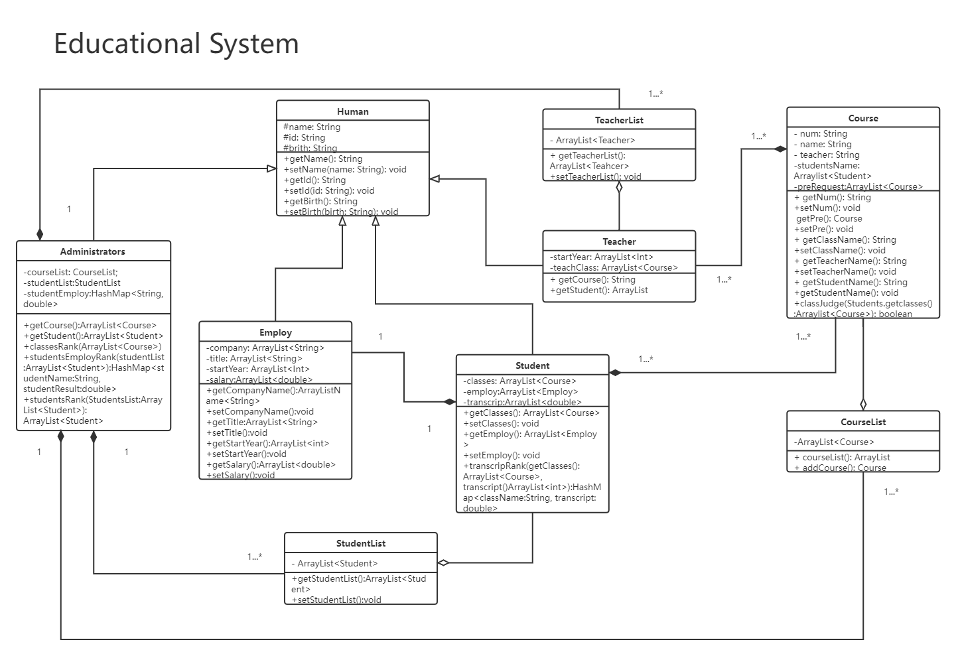

Except for classes that record human information, the system also have class for recording courses information such as classes’ name, lecturers’ information and functions to get and share their attributes and so on.

For better management of each object and ease of invocation by administrators, the system has object-array classes(TeacherList, StudentList and CourseList). Once the objects are created and once the objects are instantiated and their attributes are filled, it’s added to corresponded object-arraylist.

**The functions in student class**

Before illustrating the functions of student class, we should know the relationship between students class and employ class. These is a one to one correspondence between the objects in student class and objects in employ class binding by names and ids. In addition to the basic method to get and share students class’s attributes, the system has function transcripRank(). The method is called rank grades of the courses studied. Through calling this function, students can know their performance better and have a better understanding of the subjects you plan to choose in the future.

**The functions in course class**

There is one specialized function to course classes, courseJudge(). Since some courses may require students choose some other courses at previous semester. When students are going to choose some course to learn in later semester, this function will check student-objects’ attributes classes, to find whether there have been the prior courses in there. If it did, the students are allow to choose this course or they are not allowed.

**The functions in Administrators class**

The functions in Administrators class mainly about performance measurement. First, function classesRank(). By calling an array of course objects, the grade – related attributes of the array object are weighted, and rank, the administrators can rank the situation of all the classes, for the sake of assessing the quality of courses.

Function studentsEmployRank(), is used to assess graduate students’ career in five year. the function uses the object array of studentList(The object of student class contains an attribute which is an object of Employ class. ). By extracting the attributes such as companies name, titles and salary, the studentsEmployRank() can assess the graduate students situation.

The function studentsRank(), also using students object from studentList’s array, assesses and judge the students’ situation.

**Part of the functional Sequence diagrams display**

Table2: Sequence diagrams

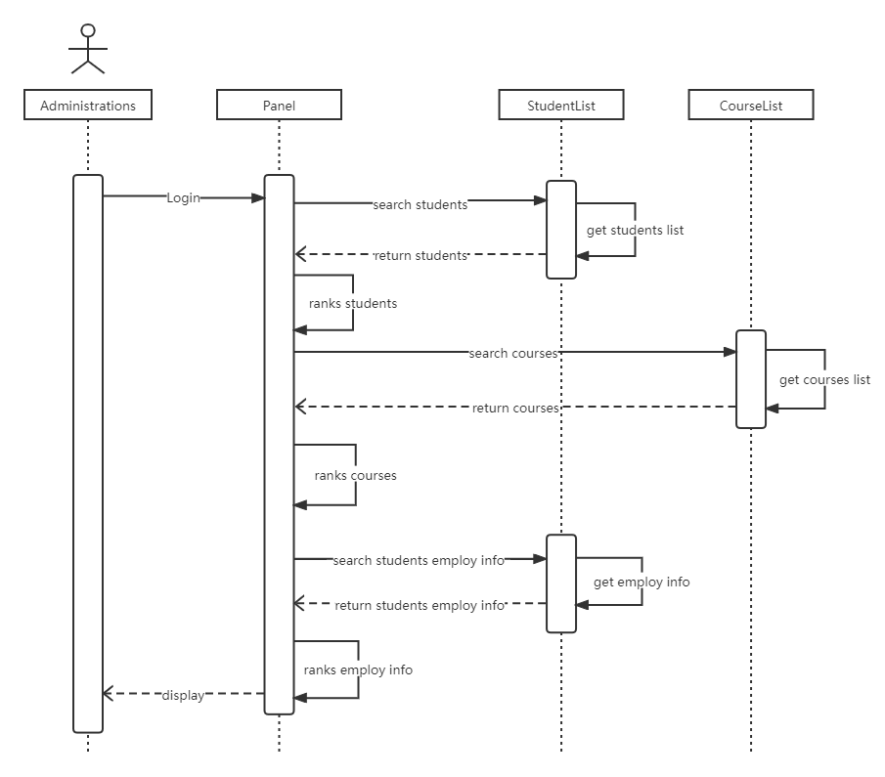

First, the manager needs to enter information to enter the control panel. Second, the manager can use different search functions to obtain different information. For example, the front end will execute the function called studentsRank() when the administrator searches for the student's ranking. After running and compiling in the background, the students' rank will be displayed in the control panel.